AUTHOR VISIT – LEXI REES
We're delighted that Lexi Rees is visiting us on Friday 5th March as part of our virtual World Book Week.
If you are interested, signed copies of her books are available to buy at discounted prices. Creative Writing Skills has also been translated into German, Italian, and Spanish. If you would like to order a copy in one of these languages – please specify this on the form.
To order your copies, please complete the form below, and return it to your class teacher. Payment in advance by Paypal (lexireads@hotmail.com) or Bank Transfer to L Rees sort code 20-80-14 account number 83160971. Please use your child’s name as the payment reference. Books will be delivered to school after lockdown.
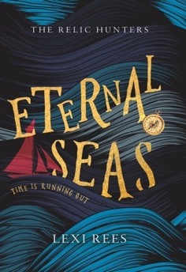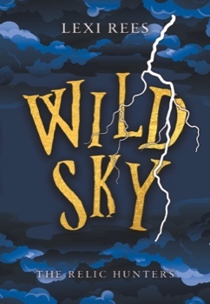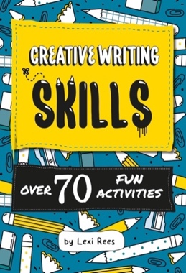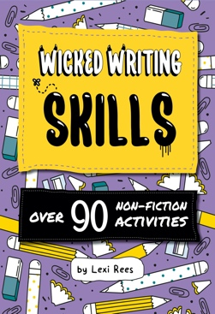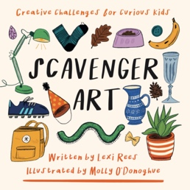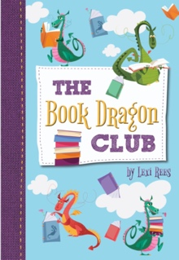
Pupil Name: ………………….………………….…………………….……. Class: …………………………

TITLE | PRICE | QUANTITY | TOTAL
Creative Writing Skills | £6 |  | £
Wicked Writing Skills | £6 |  | £
Scavenger Art | £10 |  | £
Eternal Seas, The Relic Hunters #1 | £5 |  | £
Wild Sky, The Relic Hunters #2 | £5 |  | £
The Book Dragon Club | £5 |  | £

Note on Dedications: If you’d like Lexi to add names (e.g. To Anne) when she signs your books, please write EXACTLY what you would like in each book below. Please make it clear if different names are to go in different books. Add extra lines if necessary.

………………….………………….…………………….…………………..………………….

………………….………………….…………………….…………………..………………….

………………….………………….…………………….…………………..………………….

