Sponsor Form

Mr Struck’s
Cycling Challenge
in aid of
African Vision Malawi

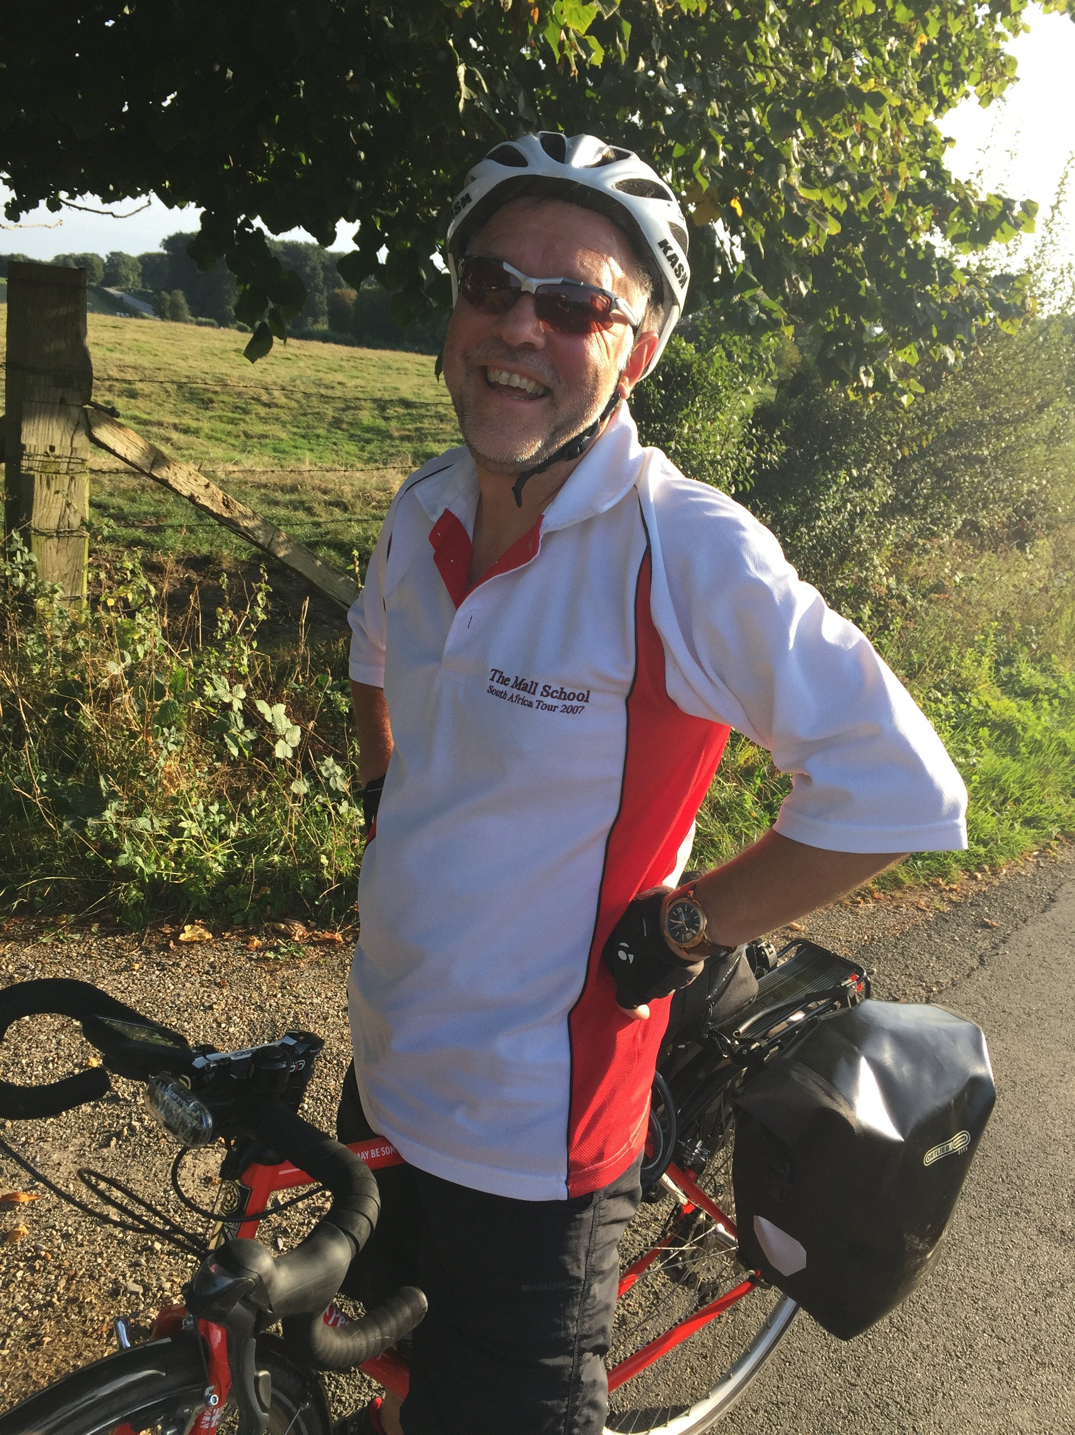
 | Name |  | Amount  per Mile | Single amount | Total Amount
1
2
3
4
5
6
7
8
9
10
11
12
13
14
15
16
17
18
19
20
Total amount:
www.follow-rainer.com

Hedgerley to Marseille
Approx. 1000 miles
May / June 2017

